Features Implemented
- Chrome browser extension to identify page DOM properties and create automation scripts
- Users can generate scripts by
  - Each and every single element in a webpage
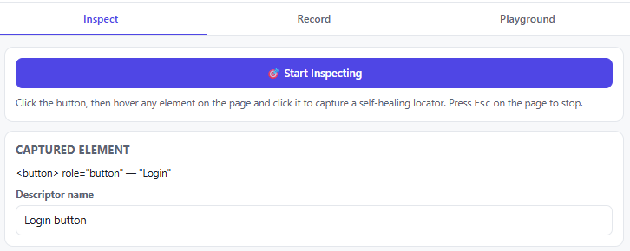
  - Record and Playback the entire workflow
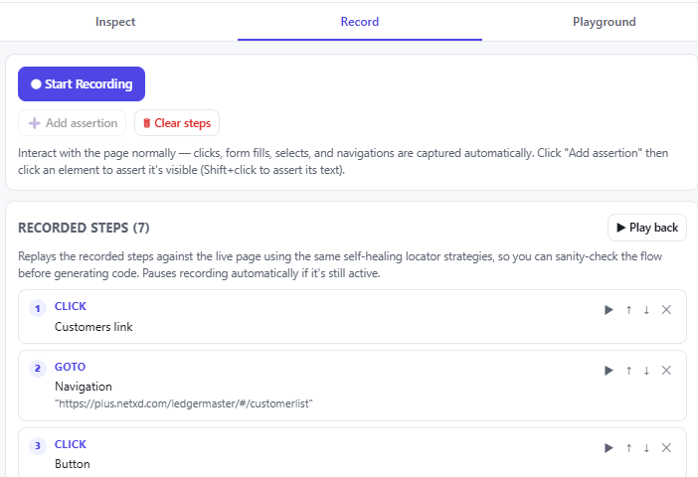
- Playground to practice locators using XPath, CSS, Data-testid value or exact visible text
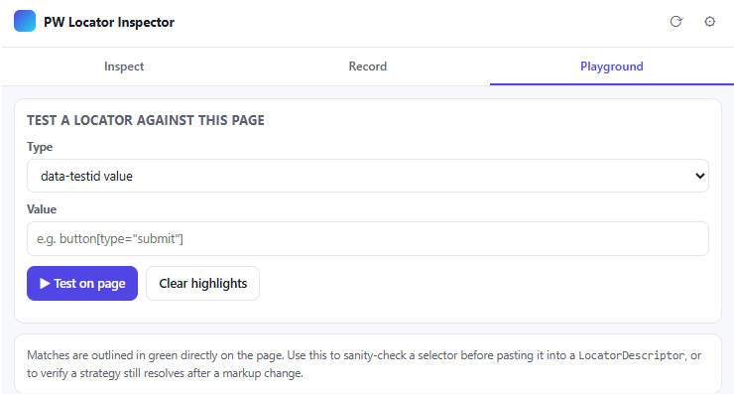

- Can create Page Object script & specification
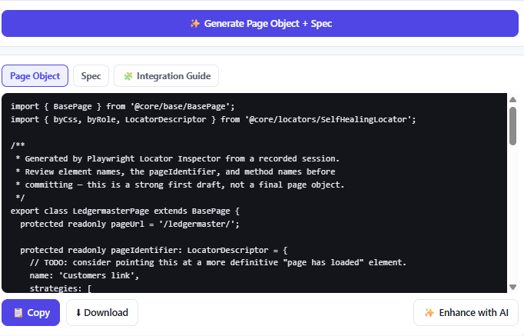
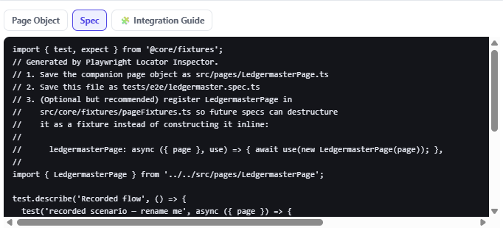

- Integration Guide to help user to add this script to my automation framework
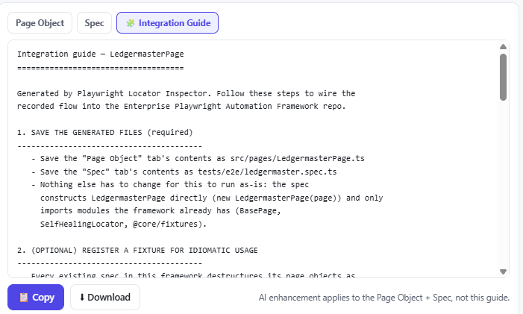

- Enhance the Page Object using AI
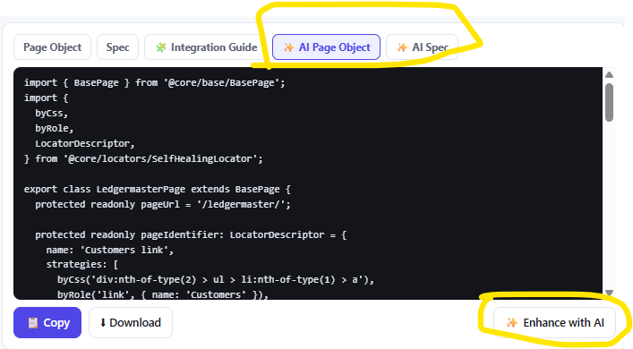

Refer attached video recording for demo.
Also refer the generated scripts, specification and integration guide files.

